- Product Overview
"The WIN-SN-TNH-ME is a versatile and reliable solution for precise temperature, humidity offering robust communication capabilities. It is ideal for measuring environmental conditions in various settings, such as industrial facilities, greenhouses, and smart homes. The module integrates a range of temperature and humidity. It provides data transmission via TCP/IP to Modbus through an Ethernet interface, ensuring seamless integration into IoT networks. The module offers flexible deployment options tailored to specific monitoring and control needs, ensuring accurate and reliable measurements over long distances with resistance to electrical interference."

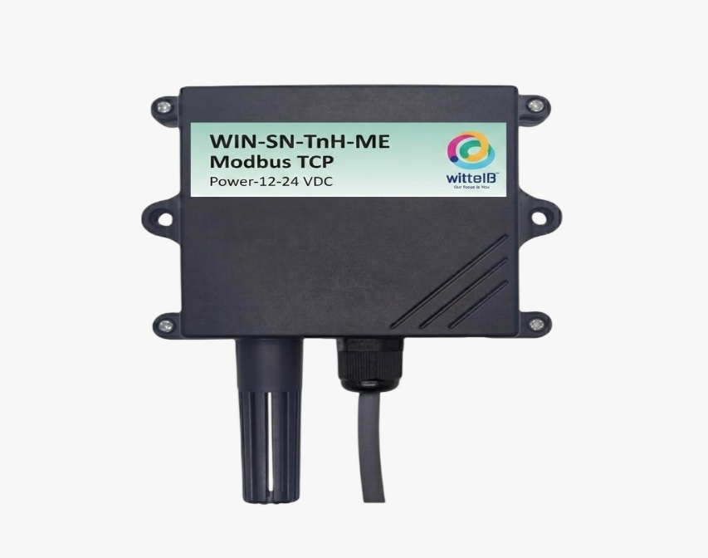

One of the key advantages of the WIN-SN-TNH-ME is its flexibility in sensor compatibility, supporting a variety of external sensors via an I2C interface. This makes it suitable for applications requiring different Applications. Powered by a 5V USB Type-C connection, this module is designed for easy integration and reliable performance in diverse IoT applications. The WIN-SN-TNH-ME supports the addition of multiple external sensors. This flexibility allows users to customize the module for various applications by integrating sensors suited to different measurement needs. Here are some examples of compatible I2C sensors listed in Table No.1.

Technical Specifications:

 | Sensor Name | Measuring parameter | Humidity Measuring range | Measuring Accuracy
☐ | AHT21 | Temperature, Humidity | -40°C ~ 120°C. | 0.3°C, 2.0 %RH
☐ | AHT20 | Temperature, Humidity | -40°C ~ 85°C. | 0.3°C, 2.0 %RH
☐ | SHT21 | Temperature, Humidity | -40°C ~ 125°C. | 0.3°C, 2.0 %RH
☐ | SHT25 | Temperature, Humidity | -40°C ~ 125°C. | 0.2°C, 1.8 %RH
☐ | BME680 | Temperature, Humidity | -40°C ~ 85°C | ±1°C, 3.0%RH
☐ | BME280 | Temperature, Humidity | -40°C ~ 125°C | ±0.3°C, ±2.0% RH
Table No.1

2. Sensor Specifications
- Wide temperature range: −40 °C to +125 °C
- Full humidity range: 0 % to 100 % RH
- Power supply DC: 12-24V@1A.
- Product dimension: 85*85*36 mm.

- Certifications:

3. Power Supply Connection
DC Connection
- Use 12-24V@ 1A, Power supply.
- Don’t make loose connection.

4. Configuration Settings
- Communication IP 192.168.0.160
- CRC Yes
- Function Code 0X03 (Read Holding Register)

Recommended Cable Electrical Characteristics
22 AWG Cable Shielded and twisted pair should be used.
Tinned Copper Recommended
Nominal Conductor DCR 14.7 ohm / 1000 ft
Nominal Capacitance 11 pf / feet (conductor to conductor)
High Frequency Non-Insertion Loss 0.5db / 100ft

5. Modbus TCP Data Storage register

ID | Function  Description | Register  Description | Modbus Function Code | Protocol | Data  Type
1 | Temperature | 40001 | 0x03 | TCP-IP | 16-bit int
2 | Humidity | 40002 | 0x03 | TCP-IP | 16-bit int

Configuration Process:-

- Power up the module by connecting a 5 Vdc 1A power supply and the RED led will be ON.

- After powering up wait for 20 Seconds.

- Enter the http://192.168.0.160/setup IP address on a web browser and a webpage with configuration pages will be accessible.

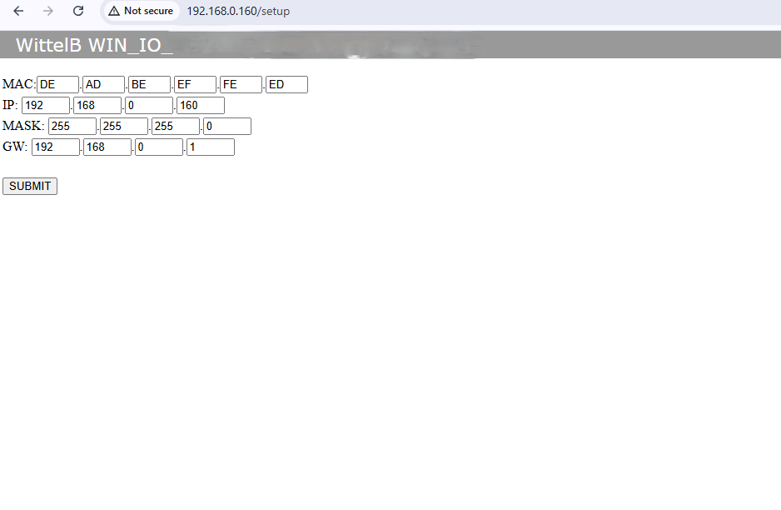
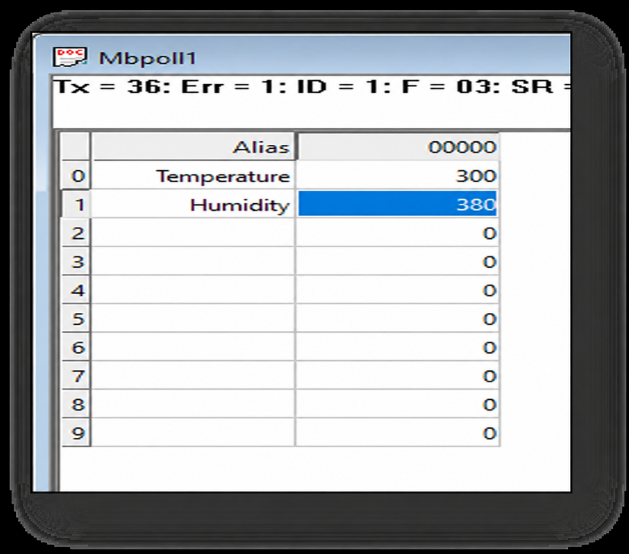
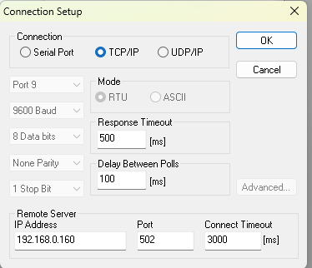
- After submitting on the webpage, you need to open MB/POLL or MBSCAN on your device. In the connection settings, select TCP/IP Connection and enter the following IP. You will receive data, and for more information, you can refer to the images below.

- Important Note:
Temperature and humidity data are provided in multiples of 10 for higher resolution. To obtain the actual readings, you need to divide the values by 10. For example:
Temperature: 300 / 10 = 30.0°C
Humidity: 380 / 10 = 38.0%
- To change the IP address, enter the default IP address 192.168.0.160/setup in a web browser. Ensure the jumper is open, as shown in Image 1.1. Update the IP address as required, then restart the device for the changes to take effect.

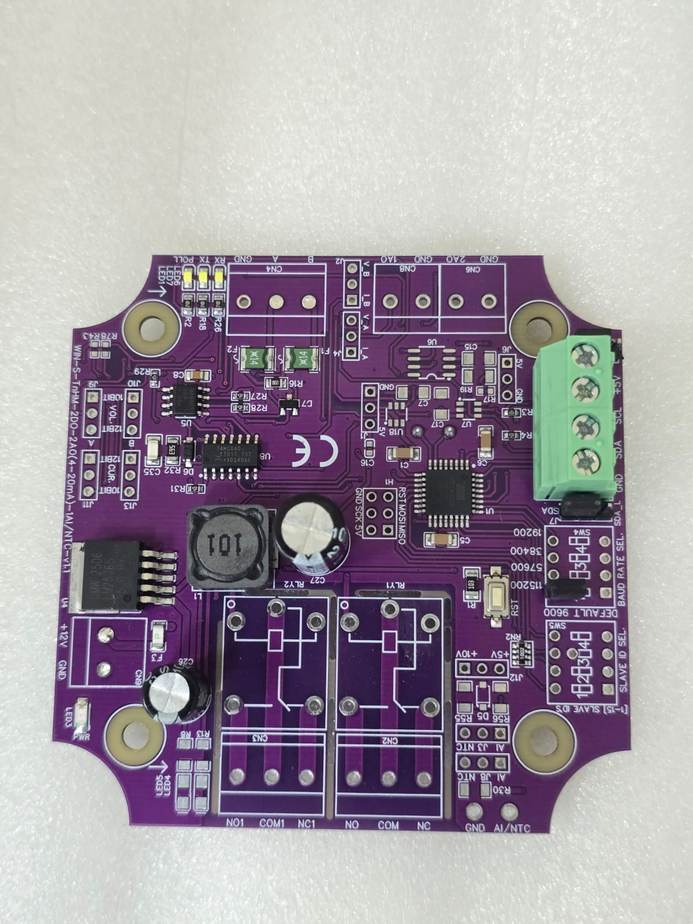
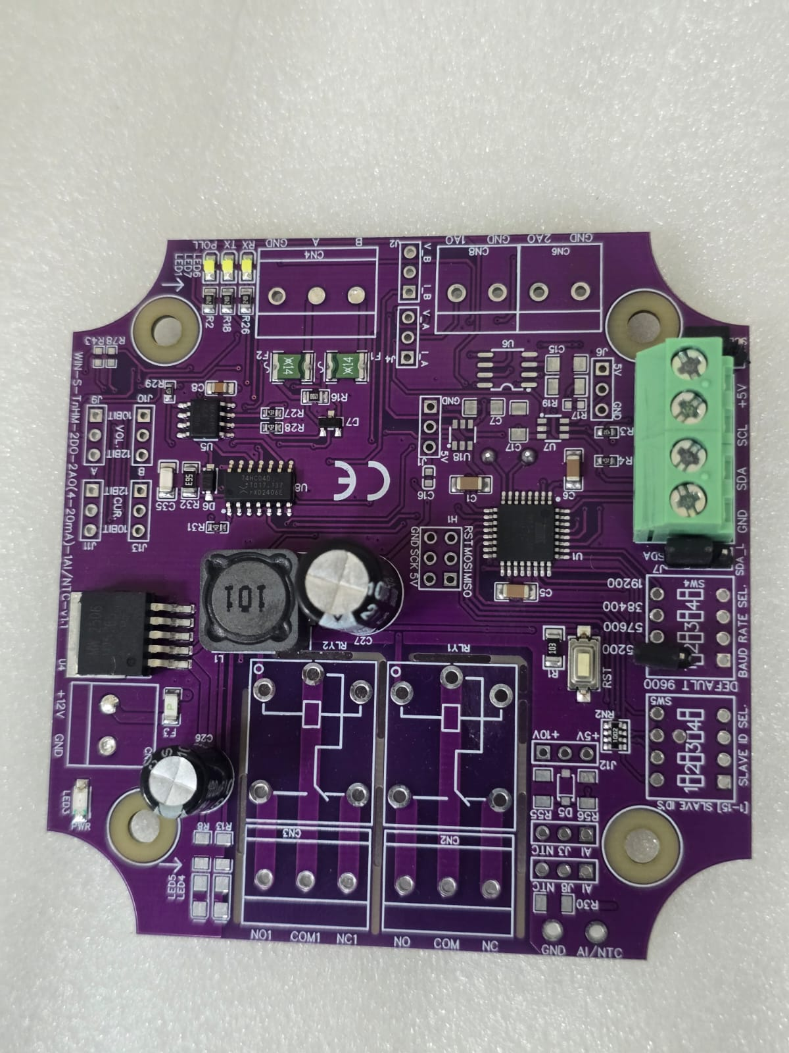

Open/Remove
Closed

Image1.1 Image1.2

Hard reset Setting
- Somehow you forgot the baud rate or slave id of the board then Place the jumper (as shown in the image 1.2) from the board reboot the system or press the reset button (given on the board). Then you will get the default IP as 192.168.0.160.

Contact Information
Augmatic Technologies Pvt. Ltd.,
Plot no 6, Shah Industrial Estate II,
Kotambi,
Vadodara – 391510.
Email – Sales@wittelb.com
Email - support@wittelb.raiseaticket.com / 9403892805

